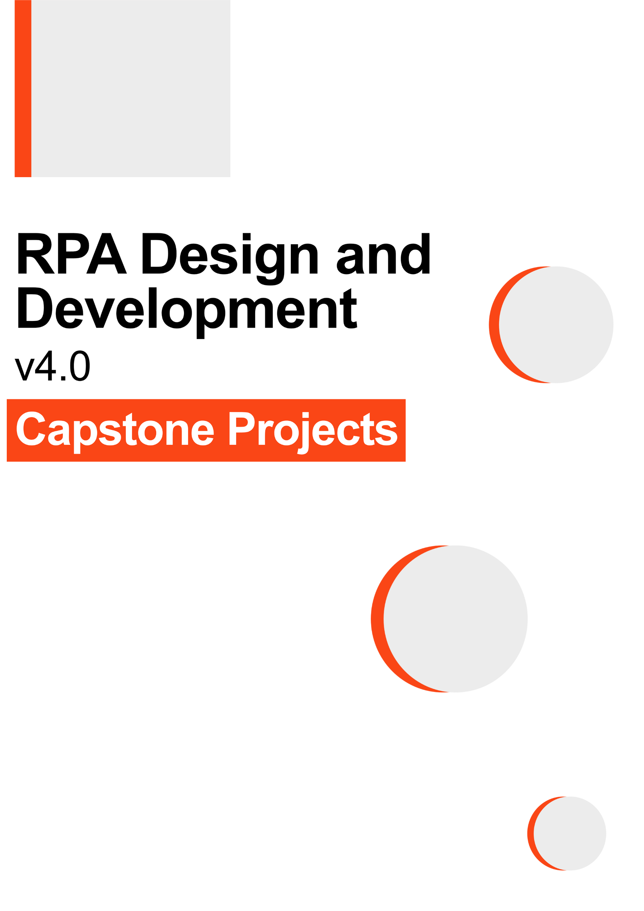

Table of Contents

1 Package Installation Guide 3

1.1 Step by step guide to install and update packages. 3

1.2 Viewing list of installed Packages 4

2 Basic Projects 5

2.1 Invoice Entry Project 5

2.2 Stock-Broker Project 7

2.3 E-mail Auto-responder Project 9

2.4 Disk Monitoring & Clean-Up Project 11

3 Advanced Projects 13

3.1 Stock Price Trend Comparison Project 13

3.2 Email Categorization Project 15

**Overview**

Robots are being implemented in business environments for automating the manual processes, thereby resulting in timesaving, and bringing efficiency in the overall operations of the organization. The manual details the system prerequisites for the successful execution of the Projects, detailed in the Capstone Projects course slide and code.

On completion of the tasks in Capstone Projects, you will be able to understand:

* The applicability of Robots in a business environment.
* Tasks which can be automated to reduce time and effort.
* Usage of different activities of UiPath studio.

This manual is divided into three chapters:

**Chapter 1: Package Installation Guide**

This chapter details the following:

1. Step by step guide to install/update packages in UiPath.
2. How to view the list of packages installed

**Chapter 2: Basic Projects**

In this chapter, the codes are basic and involve:

* UiPath activities to work on Excel, PDF, and Email.
* Connecting to an email server and performing actions.

**Chapter 3: Advanced Projects**

In this chapter, the codes are developed by using the following advanced techniques:

* Accessing websites.
* Segregating, identifying, and validating emails.

# Package Installation Guide

## Step by step guide to install and update packages.

This section will detail the system requirements and UiPath packages to be available in the system to ensure that it executes the codes correctly. Follow the steps to install the package in UiPath studio:

**Step 1.** Click on Manage Packages.



Figure 1 : Manage Packages Ribbon Bar

**Step 2.** Search the package according to the project requirement.

Figure 2 : Package Installation

**Step 3:** Select the package and the version to be installed.

**Step 4:** Save the packages by clicking on the “Save” button.

## Viewing list of installed Packages

To view the packages used in code, right-click on the “Dependencies” option of “Project” panel and select “Manage” option (refer Figure 3).

Figure 3 : Installed Packages List

Note: For the codes which involve browser usage, the browser should have its extension installed. You can install an extension from the 'Tools' section of UiPath Studio.

# Basic Projects

## Invoice Entry Project

The code comprises of six UiPath packages (refer List 1), and they must be installed in the UiPath studio for the Project to execute the task successfully.

|  |
| --- |
| * UiPath.Excel.Activities * UiPath.Mail.Activities * UiPath.PDF.Activities * UiPath.System.Activities * UiPath.UIAutomation.Activities * UiPath.WebAPI.Activities |

List 1: List of Packages used in Invoice Entry Project

The above-listed packages used can be viewed on the left side of the "Project” panel tab

(refer Figure 4).

Figure 4 List of packages used in ‘Invoice Entry’ Project

Right-click on “Dependencies” and select “Manage” to view all project dependencies (refer Figure 5).

Figure 5 Project Dependencies in ‘Invoice Entry’ Project

**Note: If a package appears in 'Red', it indicates a problem. To resolve it, right-click on the package name and click resolve/update.**

**Prerequisites:**

**An Email application is needed to receive and send emails. For this, MS Outlook is used here which is a desktop-based application. Other applications such as Gmail can also be used**

Outlook application should be configured on your system. The sender’s email credentials are also required for sending and receiving emails.

‘**Invoice Entry.exe**’ application and ‘**Sample Invoice**’ should be available in the ‘**Prerequisite**’ folder of Project folder.

The subject of the email should be ‘**Invoice**’.

The ‘**Sample Invoice**’ file should be downloaded and emailed with the subject ‘**Invoice**’ to the email id configured in outlook.

The email with the subject line as ‘**Invoice**’ should be the last unread email before running the code.

The '**Data**' folder in the '**Project**' folder should be empty before running the Project.

## Stock-Broker Project

The code comprises of three packages (refer List 2), and they must be installed in the studio for the Project to execute the task successfully.

|  |
| --- |
| * UiPath.Mail.Activities * UiPath.System.Activities * UiPath.Excel.Activities * UiPath.UIAtuomation.Activities |

List 2: List of packages used in ‘Stock Broker’ Project

The above-listed packages used can be viewed on the left side of the "Project" panel tab (refer Figure 6).

Figure 6 List of packages used in ‘Stock Broker’ Project

Right-click on "Dependencies" and select "Manage" to view all project dependencies (refer figure 7).

Figure 7 Project Dependencies in ‘Stock Broker’ Project

**Note: If a package appears in 'Red' it indicates a problem. To resolve it, right-click on the package name and click resolve/update.**

**Prerequisite:**

Outlook application should be configured on your system. The sender’s email credentials are also required for sending and receiving emails.

Microsoft Edge application should be installed on your system.

To install Microsoft Edge extension, open the UiPath studio, then click on the tools option and then enable the Microsoft Edge extension by clicking on the icon in the list of extensions.

The ‘**offer to save password**’ option should be disabled on the Edge Browser.

The Project folder should contain a ‘**Config.xlsx’** file containing the URL of ‘rpachallenge.com’ stock market page and the email address from where the email is to be sent. To make the necessary changes, please enter the URL and the email address in the **config** file.

The Project folder should contain a ‘**Rule.xlsx’** file containing the headers ‘Company Name’, ‘Expected Price’ and ‘Action’. The Project will take ‘Buy’ or ‘Sell’ actions itself based on the ‘Expected Price’. Such that, **If** (Expected Price < Current Share Price) **then** the Project will **Sell** the share and **If** (Expected Price >= Current Share Price) **then** the Project will **Buy** share.

## E-mail Auto-responder Project

The code comprises of six packages (refer List 3) and they must be installed in the studio for the Project to execute the task successfully.

* Microsoft.Activities.Extensions
* Microsoft.Rest.ClientRuntime
* UiPath.Excel.Activities
* UiPath.Mail.Activities
* UiPath.System.Activities
* UiPath.UiAutomation.Activities
* UiPath.WebAPI.Activities

List 3: List of packages used in 'E-mail Autoresponder’ Project

The above-listed packages used can be viewed on the left side of the "Project" panel tab (refer Figure 8).

Figure 8. List of Packages used in E-mail Auto-Responder’ Project

Right-click on "Dependencies" and select "Manage" to view all project dependencies (refer figure 9).

Figure 9 Project Dependencies in ‘E-mail Auto-Responder’ Project

**Note: If a package appears in 'Red' it indicates a problem. To resolve it, right-click on the package name and click resolve/update.**

**Prerequisite:**

Outlook application should be configured on your device.

‘**KeywordandResponses.xlsx**’ file should be available in the project folder.

The subject of the received email should be ‘**HelpDesk**’ and the body of the email should contain the phrase mentioned inside the keyword column of ‘**KeywordandResponses.xlsx**’ file.

**Note: The Project will send the response on the same E-mail Id from which the email was received.**

## Disk Monitoring & Clean-Up Project

The code comprises of two packages (refer List 4) and they must be installed in the studio for the Project to execute the task successfully.

* UiPath.System.Activities
* UiPath.UiAutomation.Activities
* UiPath.Excel.Activities
* UiPath.Mail.Activities

List 4: List of Packages used in 'Disk Monitoring& Clean-Up’ Project

The above-listed packages used can be viewed on the left side of the "Project" panel tab (refer Figure 10).

Figure 10 List of Packages used in 'Disk Monitoring & Clean-Up’ Project

Right-click on "Dependencies" and select "Manage" to view all project dependencies (refer figure 11).

Figure 11 Project Dependencies in ‘Disk Monitoring & Clean-up’ Project

**Note: If a package appears in 'Red' it indicates a problem. To resolve it, right-click on the package name and click resolve/update.**

**Prerequisite:**

* ‘C’ drive should be available in your system.
* Create two blank folders in 'C' drive as follows:
  + ‘new folder’
  + ‘removefolder1’

# Advanced Projects

## Stock Price Trend Comparison Project

The code comprises of four packages (refer List 5) and they must be installed in the studio for the Project to execute the task successfully.

* UiPath.Excel.Activities
* UiPath.Mail.Activities
* UiPath.System.Activities
* UiPath.UiAutomation.Activities

List 5: List of Packages used in ‘Stock Price Trend Comparison’ Project

The above-listed packages used can be viewed on the left side of the "Project" panel tab (refer Figure 12).

Figure 12 List of Packages used in ‘Stock Price Trend Comparison’ Project

Right-click on "Dependencies" and select "Manage" to view all project dependencies (refer figure 13).

Figure 13 Project Dependencies ‘Stock Price Trend Comparison’ Project

**Note: If a package appears in 'Red' it indicates a problem. To resolve it, right-click on the package name and click resolve/update.**

**Prerequisite:**

* Microsoft Edge should be installed on your system device.
* MS Office package should be installed on your system.

‘Data.xlsx’ should be present in the project folder with pre-defined values as ‘Date’ in cell A1, ‘Time Stamp’ in cell B1, ‘Exxon RPA Corp’ in cell C1 and ‘WEX Academy Inc’ in cell D1 in a sheet. A chart should also be created in the same sheet which would be used to plot the data from the columns A, B, C, and D. Initially the chart should be empty, which would be built as the data is updated in the file during the process.

‘Config.xlsx’ should be present in the project folder. In Column A of the sheet, enter Receiver’s Address, Body Message, and Mail Subject. In the adjacent cells of column B, enter your email address, a message that you want in the mail body, and ‘Stock Price Report’.

Ensure that the ‘Data.xlsx’ file (from point 1 above) is empty, and only has headers, before running the process.

‘Auto Save’ option should be disabled in excel.

Outlook application should be configured on your system. The sender’s email credentials are also required for sending and receiving emails.

* Config.xlsx file should be present in the project folder

## Email Categorization Project

The code comprises of four packages (refer List 6), and they must be installed in the studio for the Project to execute the task successfully.

* UiPath.Excel.Activities
* UiPath.Mail.Activities
* UiPath.System.Activities
* UiPath.UiAutomation.Activities

List 6: List of Packages used in ‘Email Categorization' Project

The above-listed packages used can be viewed on the left side of the "Project" panel tab (refer Figure 14).

Figure 14 List of Packages installed in ‘Email Categorization' Project

Right-click on "Dependencies" and select "Manage" to view all project dependencies (refer figure 15).

Figure 15 Project Dependencies ' Email Categorization' Project

**Note: If a package appears in 'Red' it indicates a problem. To resolve it, right-click on the package name and click resolve/update.**

**Prerequisite**

Outlook application should be configured on your device.

The Rules for the Project are stored in an excel file ‘**Rules.xlsx’** in the Project folder.

The rules for categorizing emails are based on three parameters i.e.,' From, Body, and Subject’ of the emails.

Ensure that emails should be unread, and the folder should be created where we want to move the emails as per the rules in the ‘Rules.xlsx’ file.

* The Project will use the predefined rules for the movement of incoming email to the respective folders such as Junk Email, Promotion, or Social.

Ensure that the ‘**Folder Path**’ is correctly mentioned in the ‘**Folder**’ column of the ‘**Rules.xlsx**' file. For, e.g. In the folder ‘**Promotion’** is a sub-folder in Inbox, so the path has been mentioned as ‘**Inbox\Promotion’**.